**Set common Auto growth for all the DB's in SQL Server**

<https://www.ourtechideas.com/blog/set-auto-growth/>

Below script will give the command to execute to change the database auto-growth for all User DB’s.

If you need to execute for only a single database, then please copy the relevant rows and execute.

**Note: Before changing the DB Auto Growth values, refer PAGE-2 and extract all DB Auto Growth Previous Values for safer Side.**

-- Owner: SOYELUDDIN BISWAS

-- Created Date: 24/09/2019 --

-- Email: st.biswas99@gmail.com –

USE [DBAdmin]

GO

IF OBJECT_ID('tempdb..#DBGrowth') IS NOT NULL DROP TABLE #DBGrowth

Declare @GrowthType NVARCHAR(500)

Declare @DatabaseName NVARCHAR(500)

Declare @logicalName NVARCHAR(500)

Declare @GrowthCMD NVARCHAR(500)

--######### Growth Type and Value ############

--Example, If you want set growth in % then please mention your value in % such as @GrowthType='10%'

--If want set growth in MB then please mention your value in KB such as @GrowthType='1024KB'

-- Copy the below Growth

Set @GrowthType='1024KB' --CHANGE the value here as per your requirement

Create Table #DBGrowth

(

DatabaseName NVARCHAR(500),

logicalName NVARCHAR(500),

GrowthCMD NVARCHAR(500)

)

INSERT INTO #DBGrowth

select DBS.name, DBF.name, ' ALTER DATABASE ['+DBS.name+'] MODIFY FILE ( NAME = N'''+DBF.name+''', MAXSIZE = UNLIMITED, FILEGROWTH = '+@GrowthType+' )'

from sys.databases DBS

Inner Join sys.sysaltfiles DBF ON DBS.database_id=dbf.dbid

--WHERE DBS.name IN ('master','tempdb','model','msdb') **– To Apply AG for System DB’s uncomment this.**

WHERE DBS.name NOT IN ('master','tempdb','model','msdb') – This considers all User DB’s to apply AG Value.

SELECT DatabaseName as [Database Name], logicalName as [Logical Name], GrowthCMD as [Command to execute]

FROM #DBGrowth

**Note: For Demo purpose, I’ve selected Auto Growth for System DB’s but in actual please select user DB’s**

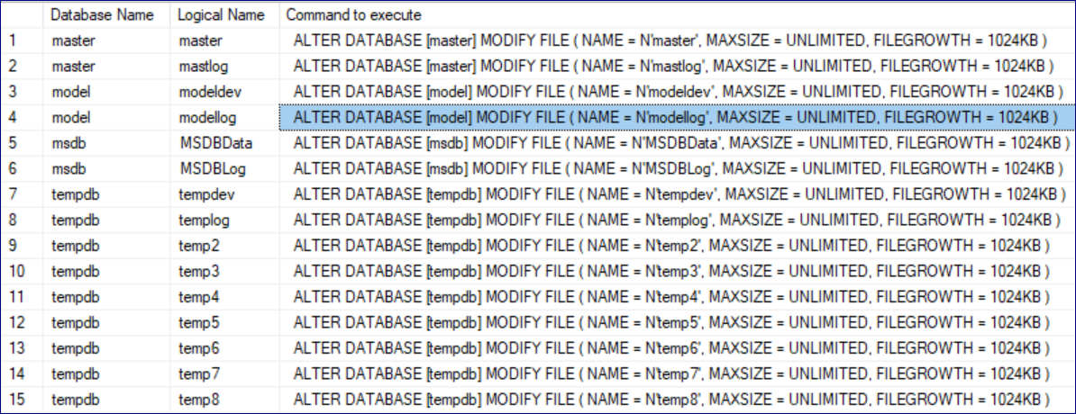

**Create below SP to extract all DB’s Auto Growth Settings.**

**USE DBAdmin**

**GO**

create procedure USP_GBAutoGrowth

as

DECLARE @SQL VARCHAR(8000), @sname VARCHAR(3)

SELECT @sname=CONVERT(VARCHAR(3),SERVERPROPERTY('PRODUCTVERSION'))

SELECT @sname=CONVERT(TINYINT,SUBSTRING(@sname,1,CHARINDEX('.',@sname)-1))

IF @sname=8

BEGIN

SET @SQL='USE ?

SELECT ''?'' [Dbname]

,[name] [Filename]

,CASE STATUS & 0x40 WHEN 0x40 THEN ''LOG'' ELSE ''ROWS'' END [Type]

,filename [FilePath]

,size/128.0 AS [TotalSize_MB]

,CONVERT(INT,FILEPROPERTY(name, ''SpaceUsed''))/128.0 [Space_Used_MB]

,CASE STATUS & 0x100000 WHEN 0x100000 THEN convert(NVARCHAR(3), growth) + ''%''

ELSE CONVERT(NVARCHAR(15), (growth * 8)/1024) + '' MB'' END [Autogrow_Value]

,CASE maxsize WHEN -1 THEN CASE growth WHEN 0 THEN ''Restricted'' ELSE N''Unlimited'' END

ELSE CONVERT(NVARCHAR(15), (maxsize * 8)/1024) + '' MB'' END [Max_Size]

FROM ?.dbo.sysfiles'

END

ELSE

BEGIN

SET @SQL=' USE ?

SELECT ''?'' [Dbname]

,[name] [Filename]

,type_desc [Type]

,physical_name [FilePath]

,CONVERT(INT,[size]/128.0) [TotalSize_MB]

,CONVERT(INT,FILEPROPERTY(name, ''SpaceUsed''))/128.0 AS [Space_Used_MB]

,CASE is_percent_growth

WHEN 1 THEN CONVERT(VARCHAR(5),growth)+''%''

ELSE CONVERT(VARCHAR(20),(growth/128))+'' MB''

END [Autogrow_Value]

,CASE max_size

WHEN -1 THEN CASE growth

WHEN 0 THEN CONVERT(VARCHAR(30),''Restricted'')

ELSE CONVERT(VARCHAR(30),''Unlimited'') END

ELSE CONVERT(VARCHAR(25),max_size/128)

END [Max_Size]

FROM ?.sys.database_files'

END

IF EXISTS(SELECT 1 FROM tempdb..sysobjects WHERE name='##Fdetails')

DROP TABLE ##Fdetails

CREATE TABLE ##Fdetails (Dbname VARCHAR(50),Filename VARCHAR(50),Type VARCHAR(10),Filepath VARCHAR(2000)

,TotalSize_MB INT,Space_Used_MB INT,Autogrow_Value VARCHAR(15),Max_Size VARCHAR(30))

INSERT INTO ##Fdetails

EXEC sp_msforeachdb @SQL

SELECT * FROM ##Fdetails ORDER BY Dbname

**Execute below SP to get all DB Auto Growth Report.**

Exec USP_GBAutoGrowth

**Sample Output:**

